**TUTORIAL**

**Getting started with** [**ThingsIO.AI**](http://thingsio.ai/)

1. Register the account in [**http://thingsio.ai/#/register**](http://thingsio.ai/#/register)**.**

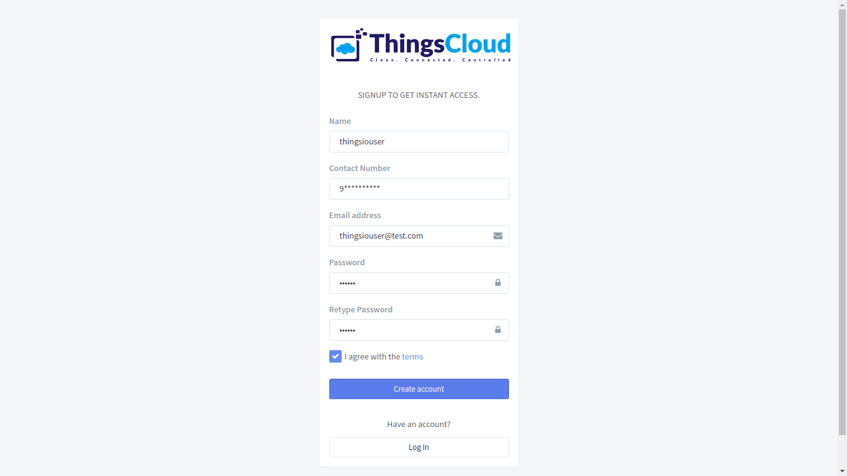

1. Create a project:

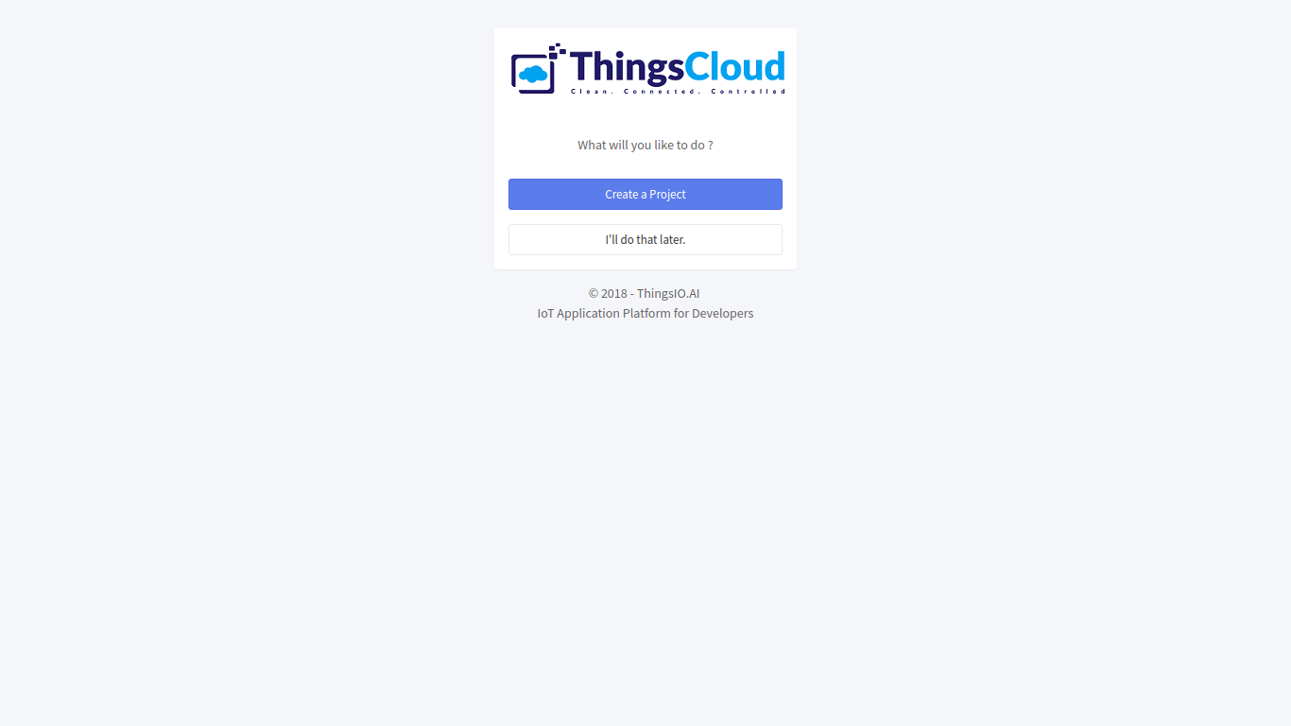

1. Write the name of the project:

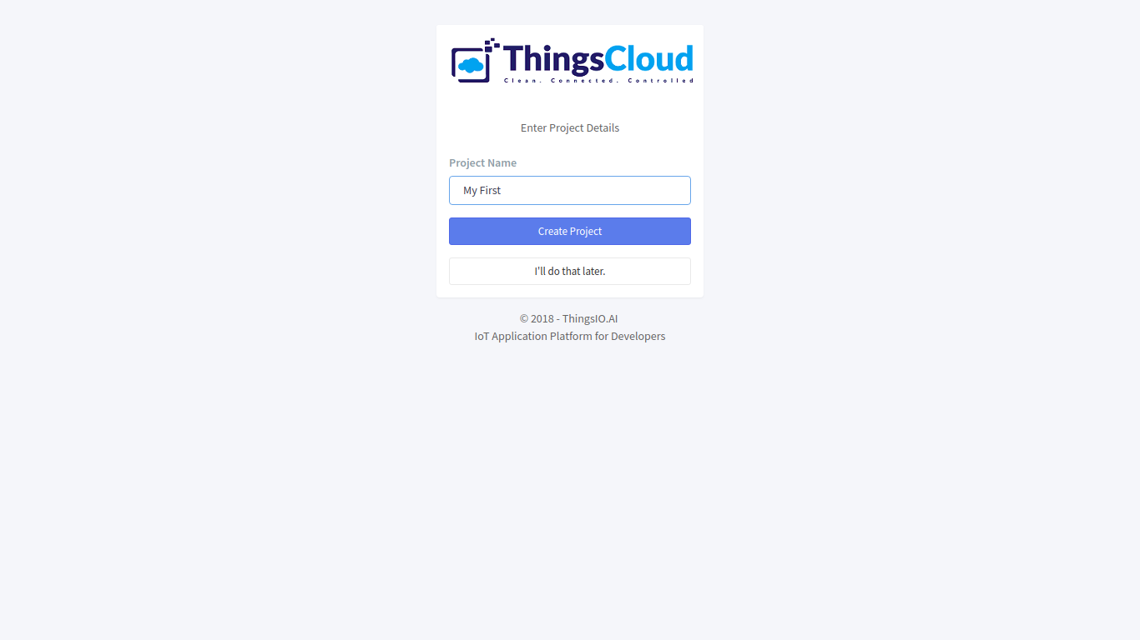

1. Now, you will be on the project dashboard of your account. Click on the new project option:

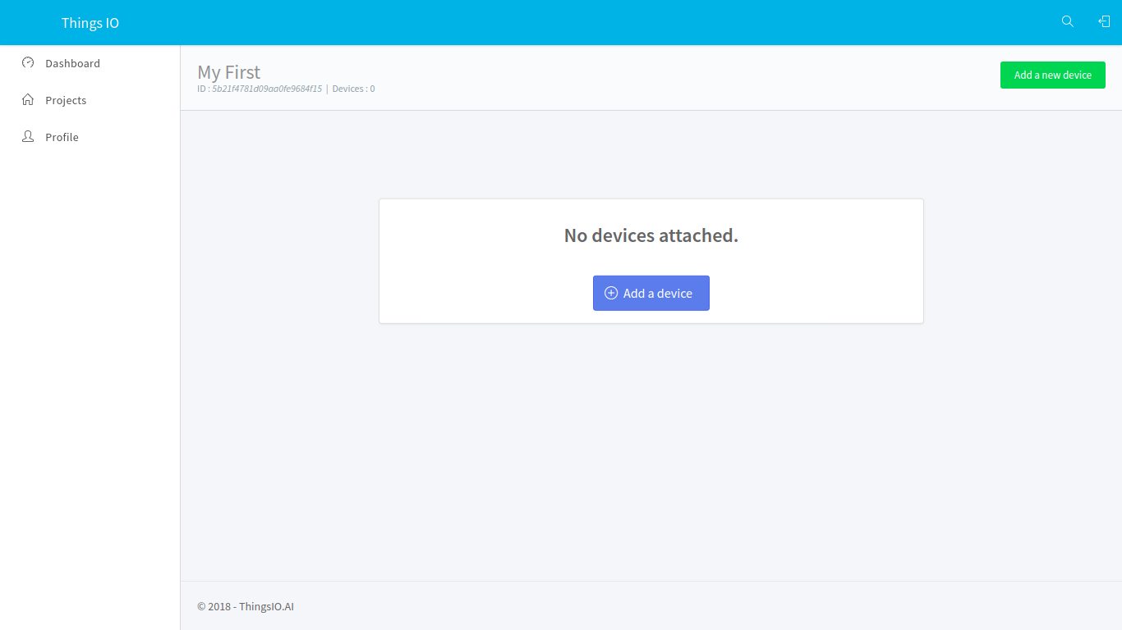

1. Click on the add a new device option:



1. Enter the device name and click on the create and configure device:

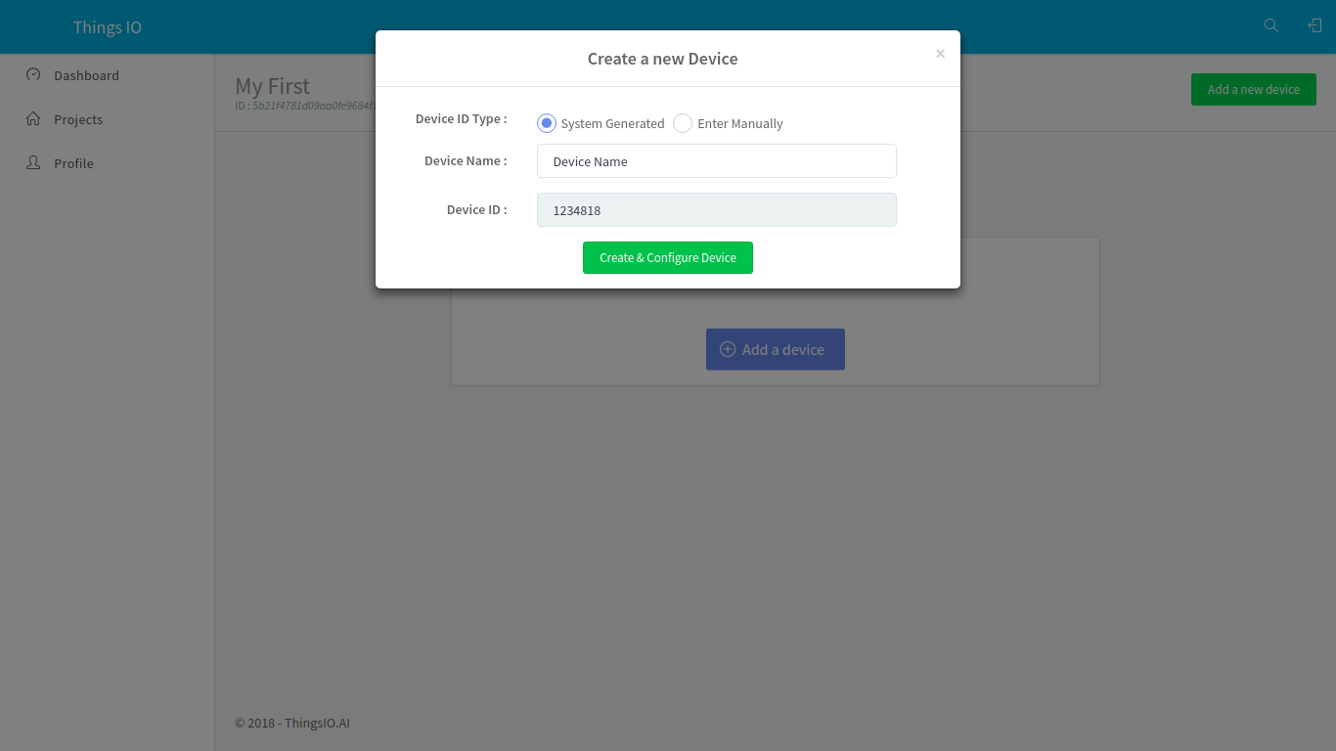

1. You will be on your device dashboard:

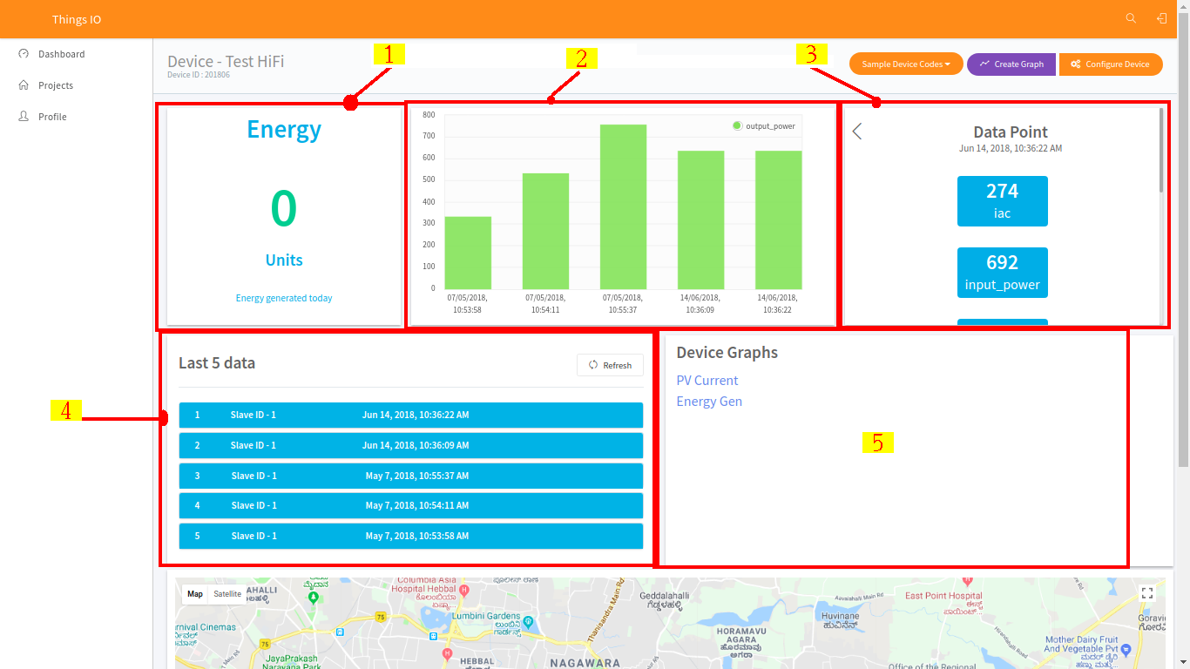

1. Track your device’s special parameters here. This can be set in device configuration (default to null).
2. You can see your real time and special parameter’s graph.
3. You can see your all data points.
4. You can see here your last 5 data points.
5. You can see here all the list of created graphs.
6. Go in sample device code options and click on the CC3200. You will get the sample code from there and paste into your CCS.

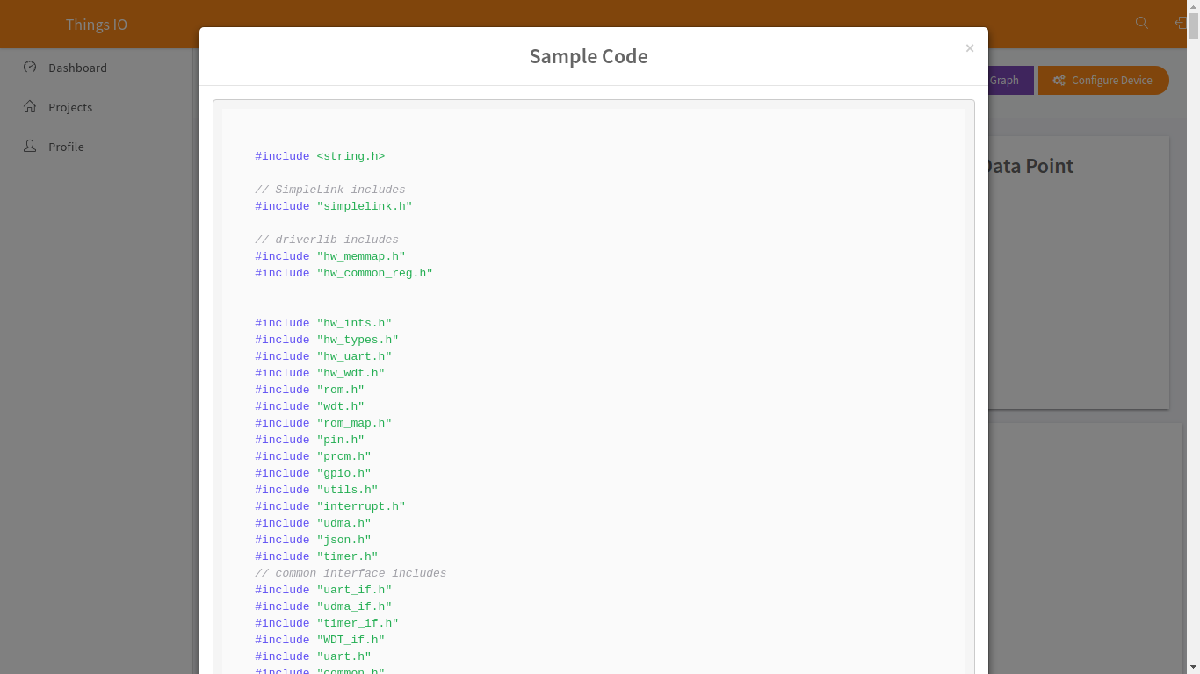

1. Click on the “Send trial data” to send a trial data to the server:

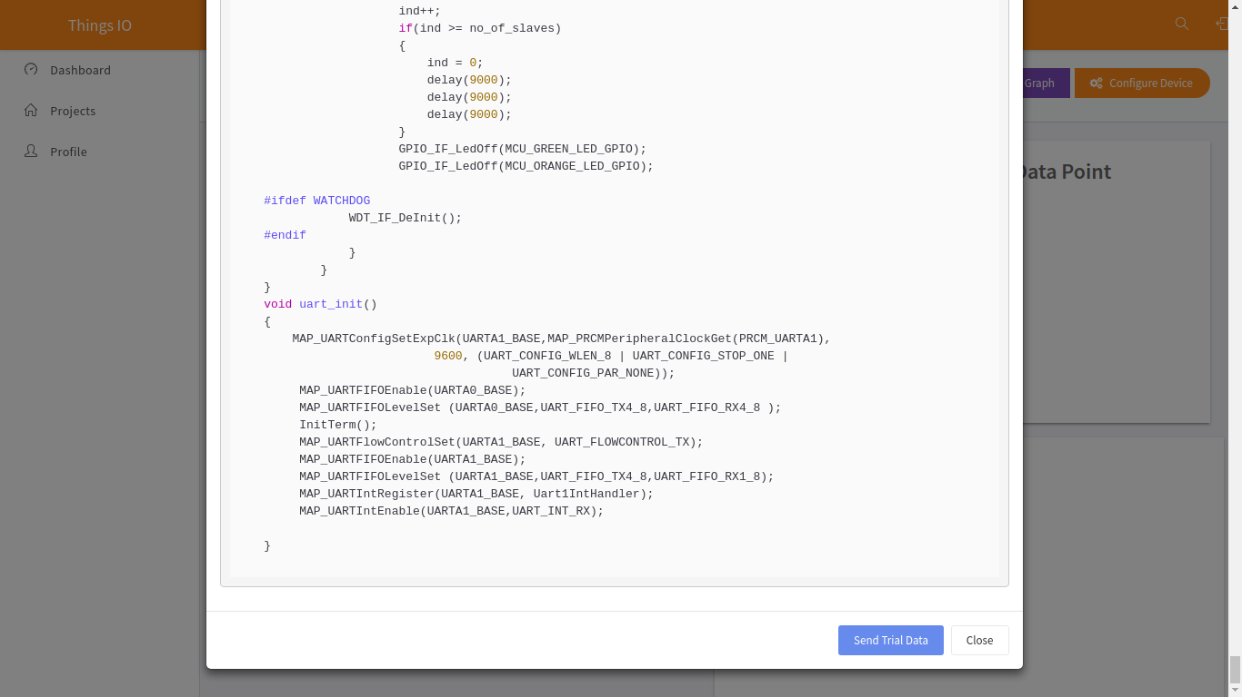

1. Now, click on the configuration device option.

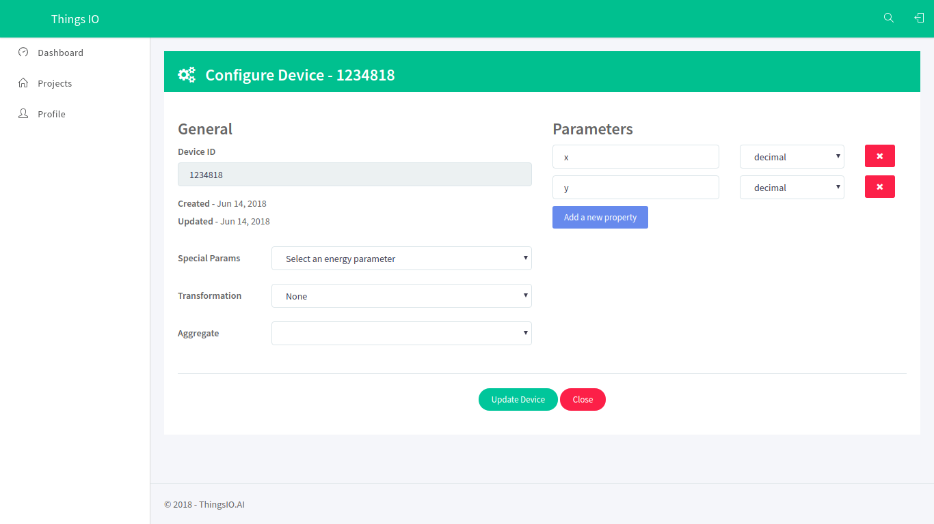

1. You can set the special parameters (this is tracked on the device dashboard) & transform it accordingly and add new parameters (Parameters are updated automatically as you send them from your device).

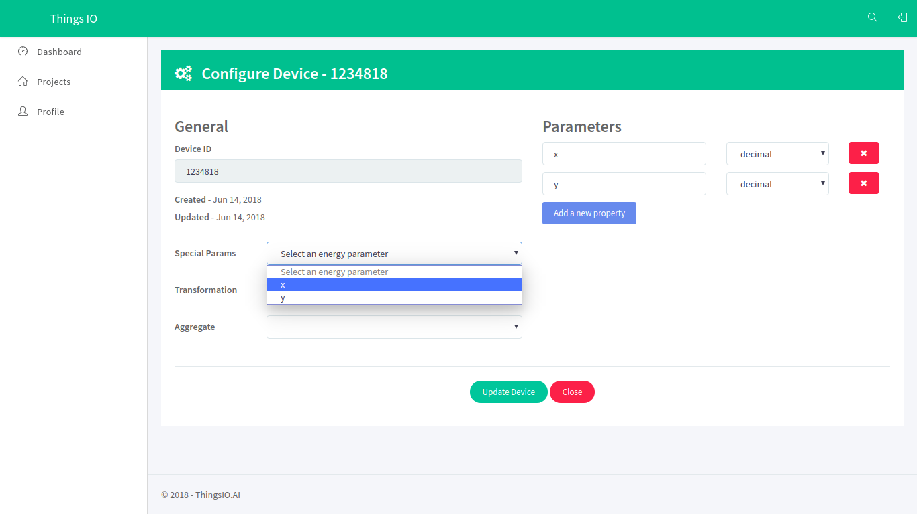

1. Click on the update device option:

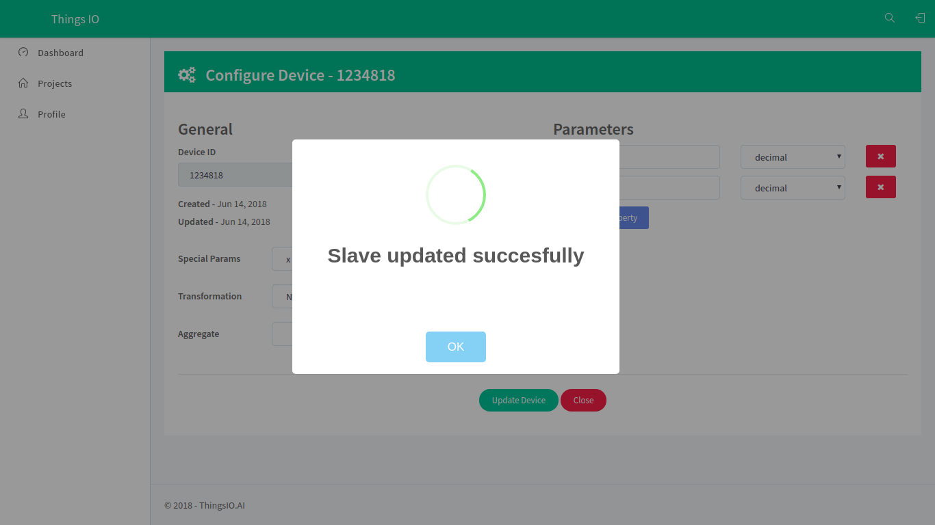

1. You can also set your device geographical location.

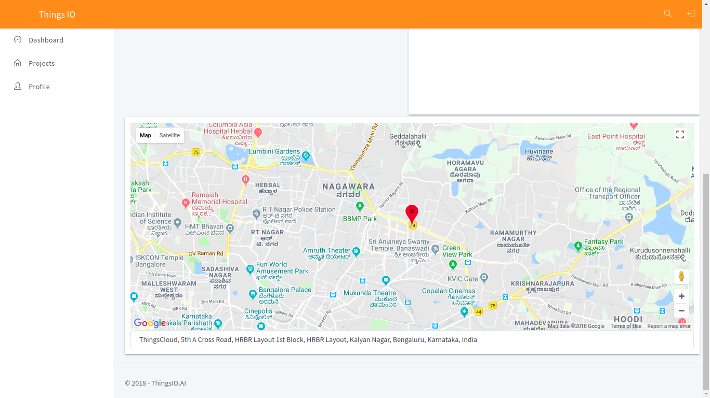

1. To create a graph for your device click on the “create graph option”.

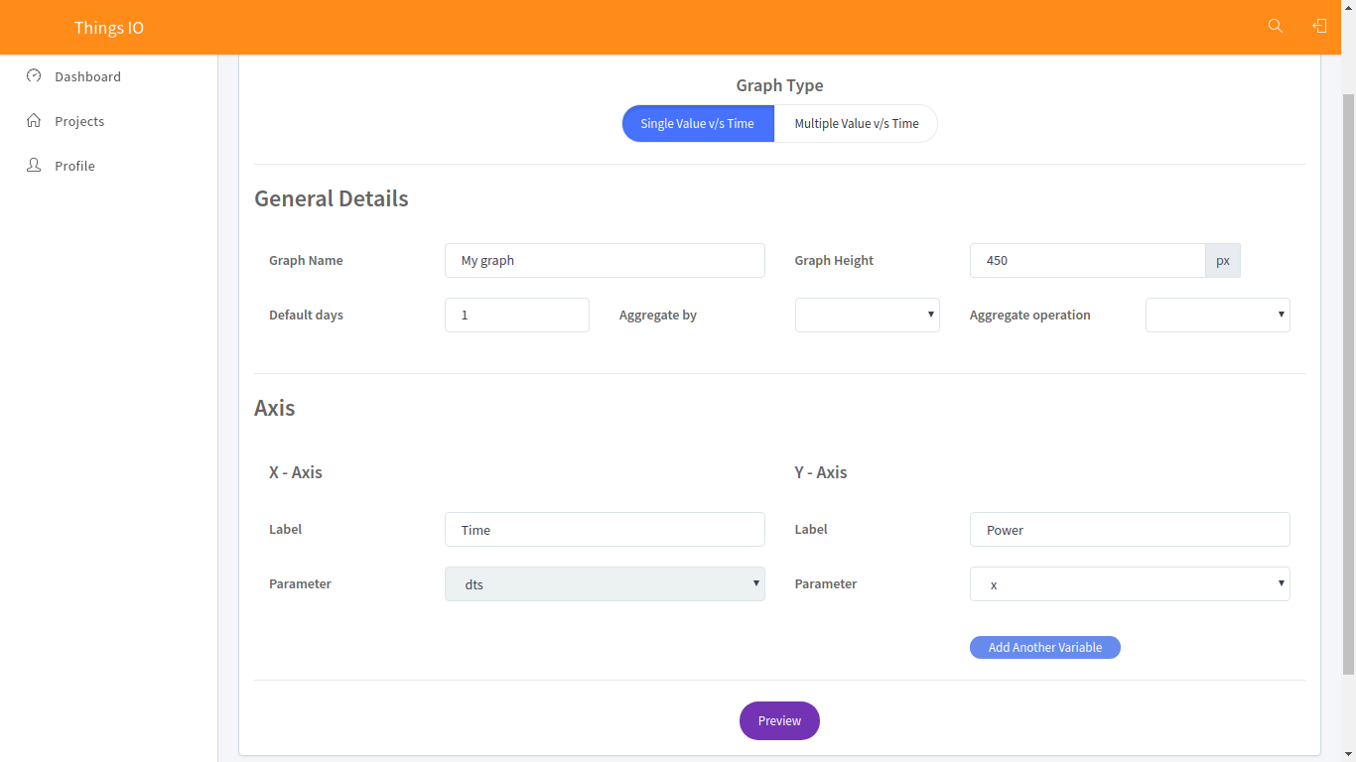

1. Click on the preview option. You will see your created graph and click save changes.

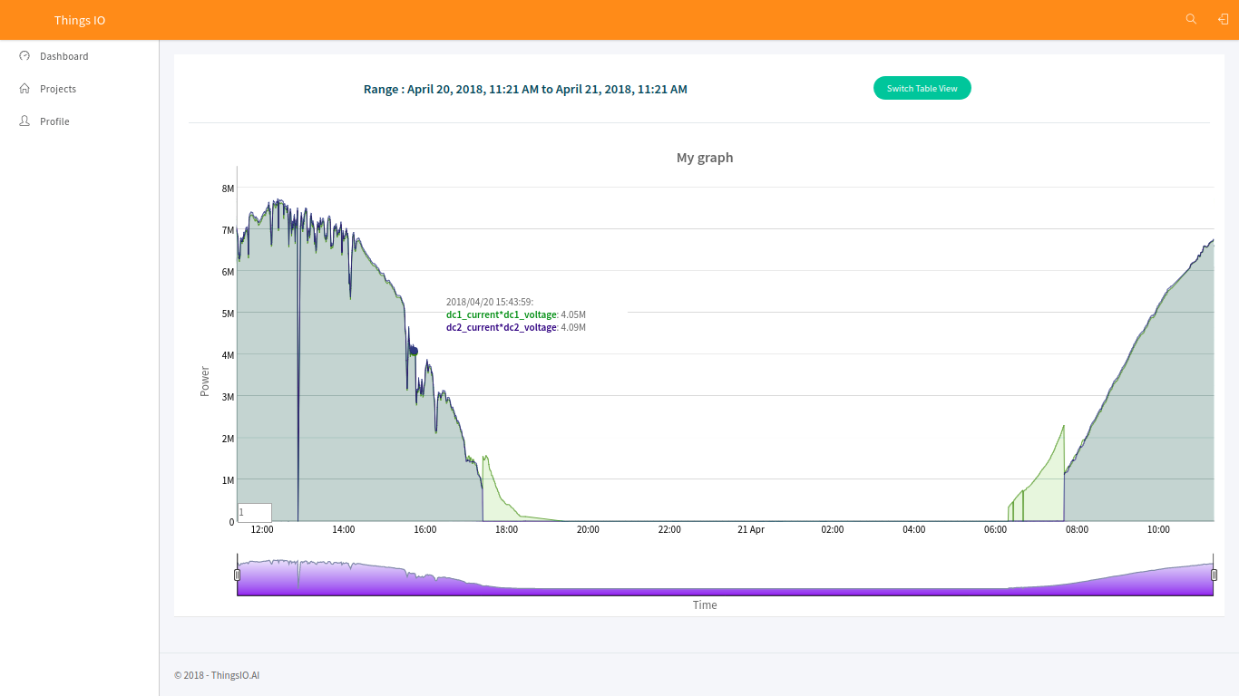

TEMPERATURE SENSOR WITH NODE MCU

PLATFORM: WINDOWS

IDE: ARDUINO

CHIP: ESP8266 MOD WiFi MODULE

1.LIBRARIES INCLUDED

**a**) #**include <SoftwareSerial.h>**

* Install arduino IDE
* Go to sketch>include library>library manager>search software serial>install
* Checkout the link provided for the detailed video on how to setup Arduino tool chain and libary for ESP8266: <https://youtu.be/ftO-_nfBBZk>

**b**) #**include <ESP8266WiFi.h>**

* (https://github.com/esp8266/Arduino )

**c) #include <DNSServer.h>**

* Go to sketch>include library>library manager>search DNSserver>install

**d) #include <ESP8266WebServer.h>**

* Go to sketch>include library>library manager>search >install

**e) #include "WiFiManager.h"**

* (https://github.com/tzapu/WiFiManager)

2. CODE MODIFICATIONS

**a)** define the host

const char* host = "api.thingsio.ai";

**b**) define the post url

const char* post_url = "/devices/deviceData";

3. TEMPERATURE SENSING AND CONVERSION

switch(qry[3])

{

**1) case 0x20:**

t1=(analogValue/1024.0) * 3300; (analogValue = analogRead(outputpin),

(outputpin= A0);

Serial.print("temp: ");

Serial.println(t1);

break;

**2) case 0x21:**

do the following to obtain the Celsius value,

t2=t1/10;

Serial.print("celc: ");

Serial.println(t2);

break;

**3) case 0x22:**

t3=((t2 * 9)/5 + 32);

celcius to Fahrenheit conversion

Serial.print("fhrn: ");

Serial.println(t3);

break;

*You can modify the code as per the requirements and the sensor used

provide the device id as well as the slave id

String PostValue = "{\"device_id\": 201840, \"slave_id\": 2";

Post the values

PostValue = PostValue + ",\"dts\":" +timestamp;

PostValue = PostValue +",\"data\":{\"celc\":" + t2 +",\"fahr\":" + t3 +"}"+"}";

* Celc 🡪temperature in celcius
* Fahr🡪temperature in Fahrenheit